1. Pre requisites:

* **Visual Studio Professional 2015**
* **.NET 4.6.1 installed- You ca download the same from** [**http://go.microsoft.com/fwlink/?linkid=671744**](http://go.microsoft.com/fwlink/?linkid=671744)

1. UnZip the project and save into a folder
2. Open Visual Studio . Navigate to **File-> Open-> Project/Solution**

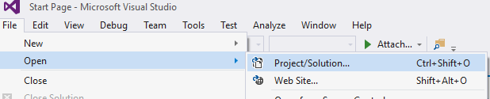

1. Select the .sln file from the unzipped folder path:

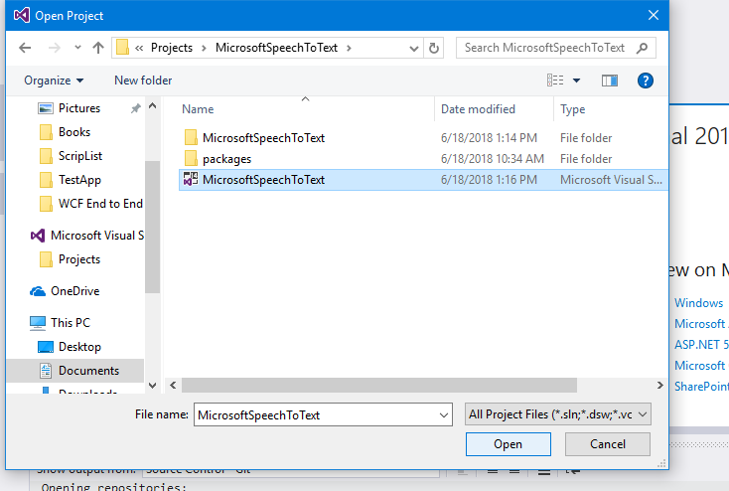

1. You should be able to view Solution Explorer window on right side. If not open, select solution explorer from **View-> Solution explorer**

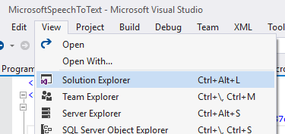

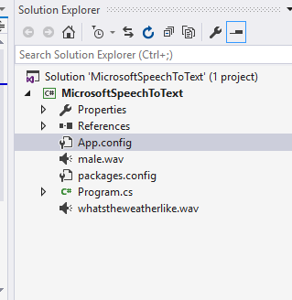

1. **Open App.Config** file from solution explorer and **change to your subscription key and Service Region** under App settings section:

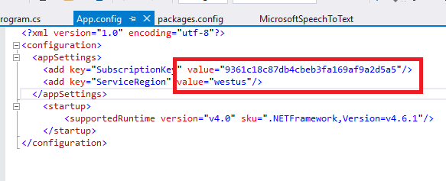

1. Make sure that target framework is 4.6.1 by **right clicking on project name-> properties->Application:**

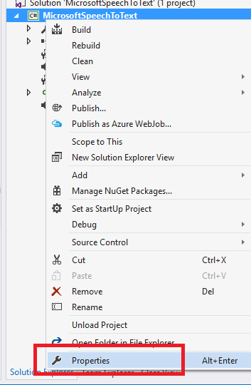

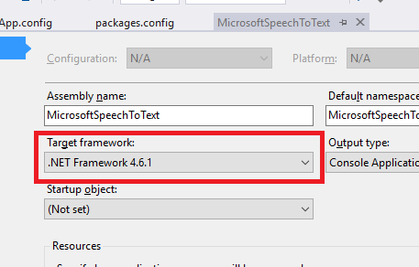

1. **Right click on Solution Name and choose Rebuild Soultion option** to build your app:

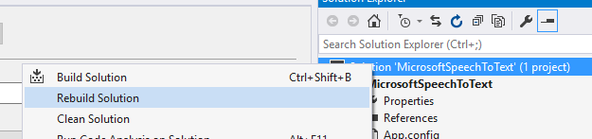

1. If everything is working fine, you should be successfully able to build without any errors in Output window at the bottom of the Visual studio:

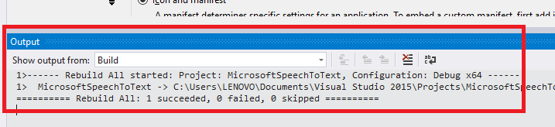

1. Now run the app. **By clicking on Start :**

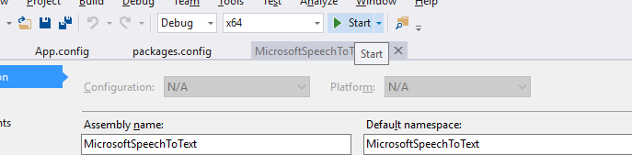

You should be able to see a black command window:

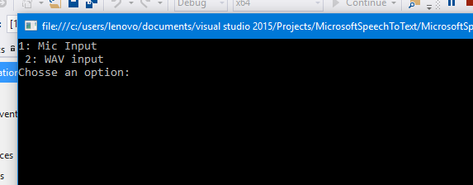

1. For recognizing from your laptop mic, select **option 1 and speak clearly and loudly**:

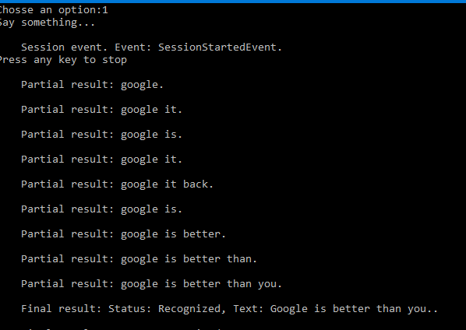

The app recognizes continuous speech with many partial results. And then final results. It will be listening to your mic for an indefinite amount of time. You can speak for as long as you want.

To stop recording, press any key. The command window should disappear and the app is no longer running.

1. For WAV file input, run the app again and **choose option 2 and enter a file name**( I have tested with only WAV files. Not sure about MP3). (The file duration shouldn’t be a matter. I have tested with a 51 sec WAV file without getting any error)

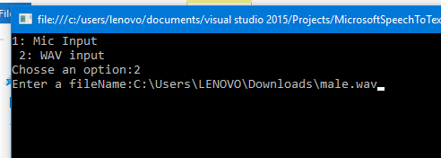

You should be able to see multiple partial results and a final result at last.

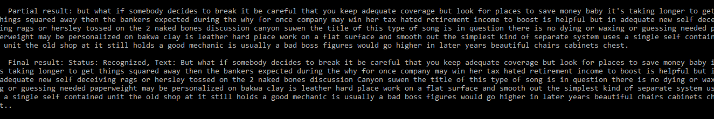

To stop recognizing, press any key on the command window. It should disappear and the app is no longer running.